Process Documentation
16.11.2025
- creating a GitHub repository
- Setting up a README file
- Setting up a Process Documentation file
30.11.2025
-creating a To-Do list:
-Lights
-Servo
-Sound
-making it Pretty
Laying out all the objects I would consider using:
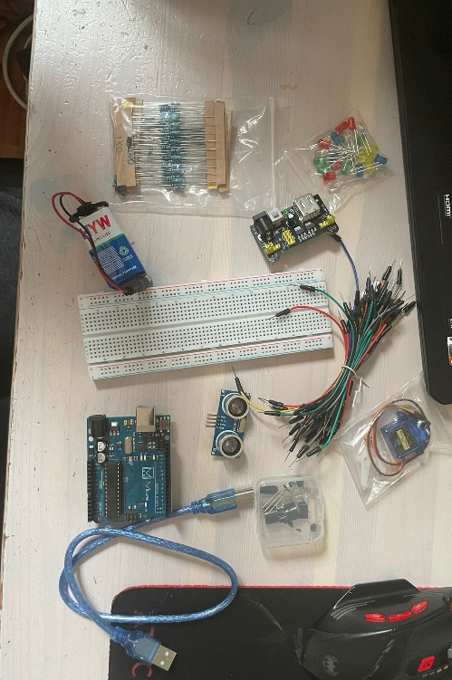
Why I didn’t use..
Battery: I connected a lot of devices and let them run while coding and I didn’t want my battery to run out during the trials
Distance sensor: this was an optional for me from the beginning, and I had two issues, first of all there was already a lot of pin compilations and I didn’t want to risk another one. Second I didn’t really see how I could include it in my creative packaging without making it stand out.
Lights:
- plugging in all lights
- Plugging in all grounds
- plugging in all resistors
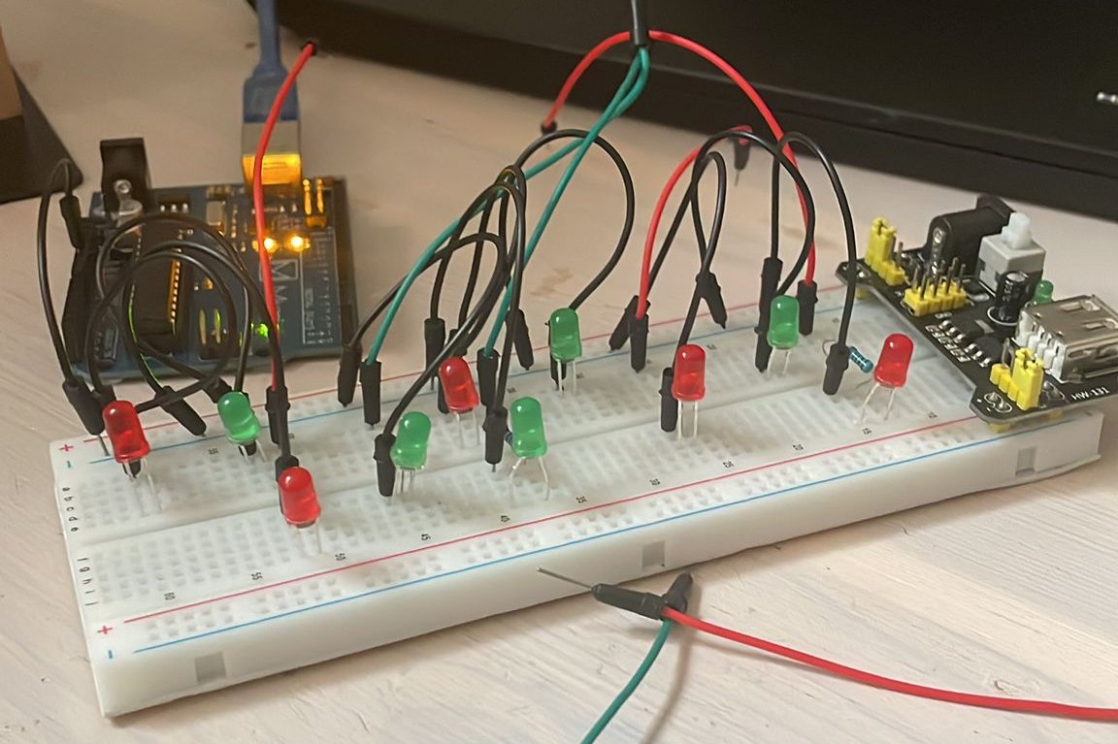
- testing all lights
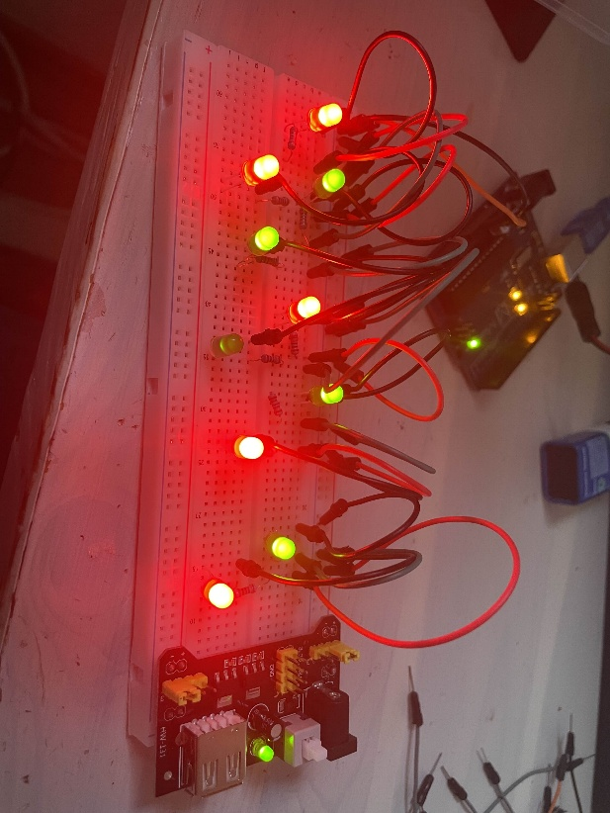
- coding the code to make them flicker at random like a stormy cloud
  - set-up for the pins
  - working with random so that the LEDs seem to be lighting up in a natural manner
  - the LEDs slowly light up and dim down in a random time frame with a random delay

Music:
- connecting the buzzer
- writing the music code
- adding a pitches.h file
- finding a Christmas song online
- had to rewire, cause pin 3 and 11 were colliding with the sound
- fixing this issue in code: [Video 1]

- fixed it by rewiring
- set-up the buzzer and making the music play separated from the lights

Servo:
- got the servo wired and working but still complications between Servo and lights
- A lot of rewiring and trial and error, because the Servo lagged -> I suspect that the Servo tried to follow the clock of the LEDs
- Okay, tried everything and concluded that I can only use 6 and 7 for my LEDs, sadly only have to different rhythms for my light cloud now.
My final Set up:
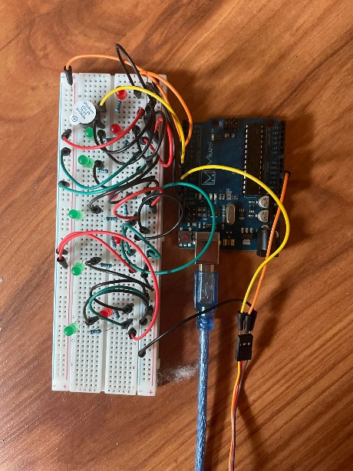
Pretty:
- Having to rearrange the lightbulbs, because the greens ones are a lot duller
- Putting cotton over the LEDs to make it look like a cloud

Sources:
- The official Arduino Docs
- The slides from class
- My notes from class
- https://www.hibit.dev/posts/31/play-christmas-melody-with-arduino-and-a-buzzer ( for the song)
- A lot of reddit and pages alike

